Please use the following sample social media messages to be a big voice for babies on Twitter and Facebook! To download the sharegraphics, right click and select “save as picture.” Remember to always use the hashtag #ThinkBabiesNC and tag us at @NCEarlyEdCo on Twitter and @NCEarlyEdCoalition on Facebook so that we can help amplify your messages.
It's Time to Think Babies™ NC
- Let’s #ThinkBabiesNC and focus on what all children and families in NC need to thrive: healthy beginnings, supported families, and access to high-quality early care and learning experiences.
- When we support children in their earliest years, we prepare our babies to grow, learn and succeed—and our communities, workforce and economy become stronger and more productive. #ThinkBabiesNC
- Brains are built, not born. During the first years of life, babies’ experiences are built into their bodies — shaping brain development and building the foundation for all future learning, behavior and health. #ThinkBabiesNC
- In the first few years #babies brains form more than 1 million new neural connections every second. That’s a whole lot of brainpower! #ThinkBabiesNC
- All parents are stretched in the earliest months and years of their child’s life. Our state and our communities all have a role to play in providing parents with support they may need at this especially critical time. #ThinkBabiesNC
- The greatest opportunity to give our children the best chance to succeed starts early. Just one more reason to #ThinkBabiesNC
- We must make the potential of #babies our top priority. It’s time for all of us to #ThinkBabiesNC.

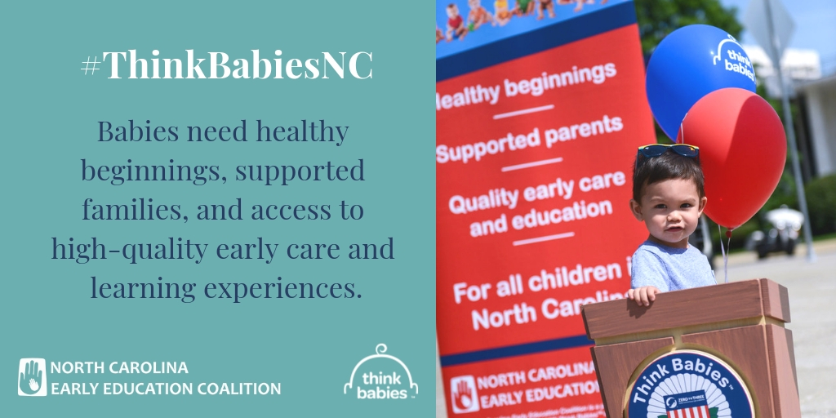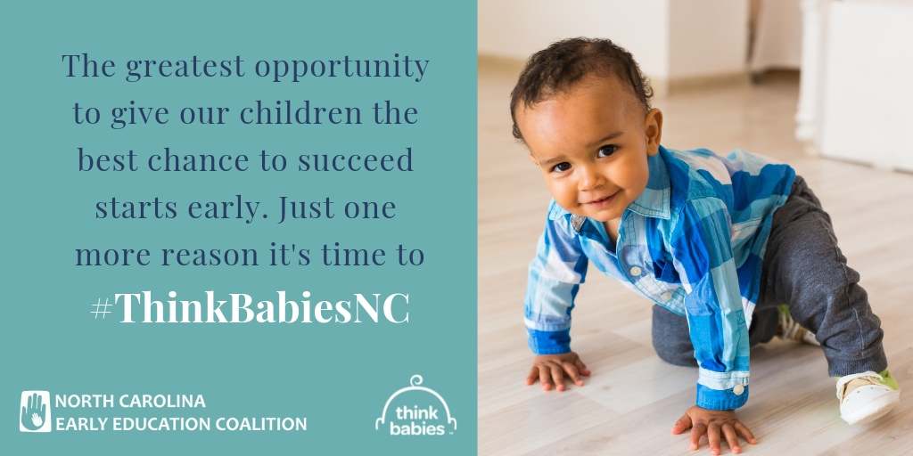

Sample posts and sharegraphics on the topics of healthy beginnings, supported families, and early care and education are all available at https://www.ncearlyeducationcoalition.org.

