Please use the following sample social media messages to be a big voice for babies on Twitter and Facebook! To download the sharegraphics, right click and select “save as picture.” Remember to always use the hashtag #ThinkBabiesNC and tag us at @NCEarlyEdCo on Twitter and @NCEarlyEdCoalition on Facebook so that we can help amplify your messages.
Early Care and Education
Child Care Subsidy Expansion
- Child care subsidies help working families pay for #childcare and provide children with access to high-quality early education. Children’s development and learning in the first few years lay the foundation for all of the years that follow. #ThinkBabiesNC
- More than 1/2 of children under 3 live in low-income families and 100,000+ babies are eligible for child care subsidy, but only 19% received it in 2018. We must increase $$ for child care subsidy to serve more of our youngest children and their families. #ThinkBabiesNC
- Working families need access to affordable, high-quality child care for their babies, but the annual average cost of infant care in NC is more expensive than the annual cost of public college tuition, rent, or food and transportation. #ThinkBabiesNC
- High-quality #childcare is out of reach for too many low-income working families without subsidies. A single parent earning minimum wage would need to spend 61.4% of their income on child care for 1 infant. #ThinkBabiesNC
- 67% of young children in NC live in households where both parents are working. But almost every county in NC has a child care subsidy shortage, serving less than 1/3 of all eligible infants and toddlers. #ThinkBabiesNC
- Infants and toddlers wait longer for child care subsidy assistance, missing crucial developmental opportunities. More than half of young children on the child care subsidy wait list are below age 3. #ThinkBabiesNC
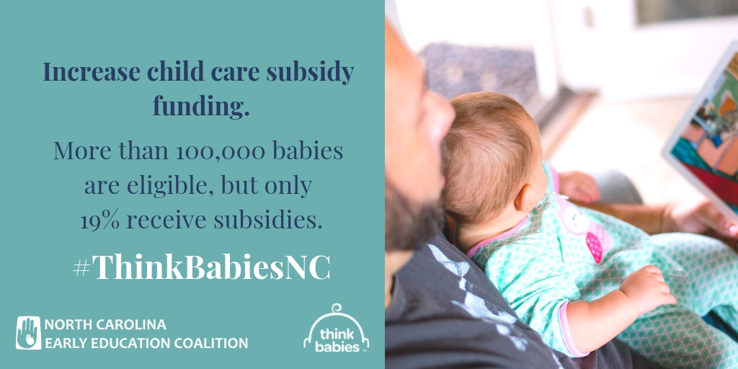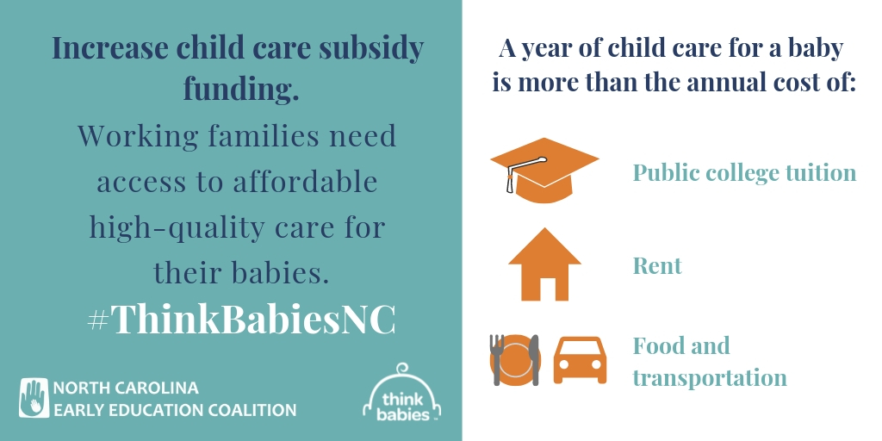

Child Care Deserts
- More than 5 families with babies are competing for every 1 available licensed #childcare space in NC. It’s time to expand high-quality infant-toddler programs across the state. #ThinkBabiesNC
- Infants and toddlers need high-quality child care to support their healthy development, but 99 out of 100 counties in NC qualify as a child care desert. #ThinkBabiesNC
- We need a solution to address the acute shortage of quality infant toddler care which exists in almost every county in the state. Less than 20% of the infant-toddler population can be served in the existing supply of licensed programs. #ThinkBabiesNC
- The #childcare shortage in NC creates a crisis for working families who need high-quality care for their babies in order to maintain employment and financially support their families. #ThinkBabiesNC
- High-quality programs are especially scarce in rural counties. A third of all counties in NC have 5 or fewer high-quality programs serving babies, and 2 counties don’t have a single one. #ThinkBabiesNC
- Voters across the state don’t have infant and toddler programs in their area that are both high-quality and affordable. Learn how policymakers can build a stronger North Carolina by strengthening families: buildthefoundation.org/2018-voter-poll-tookit #ThinkBabiesNC

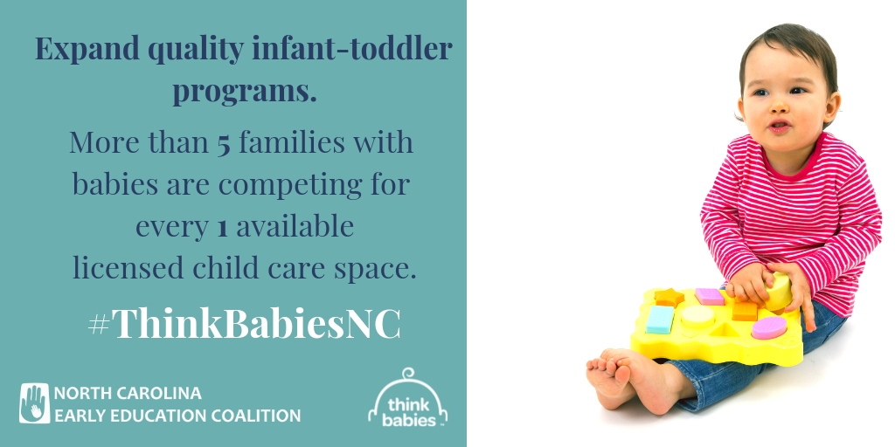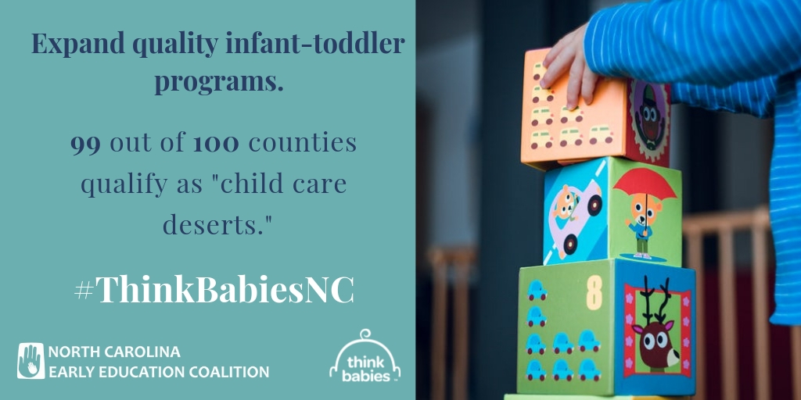

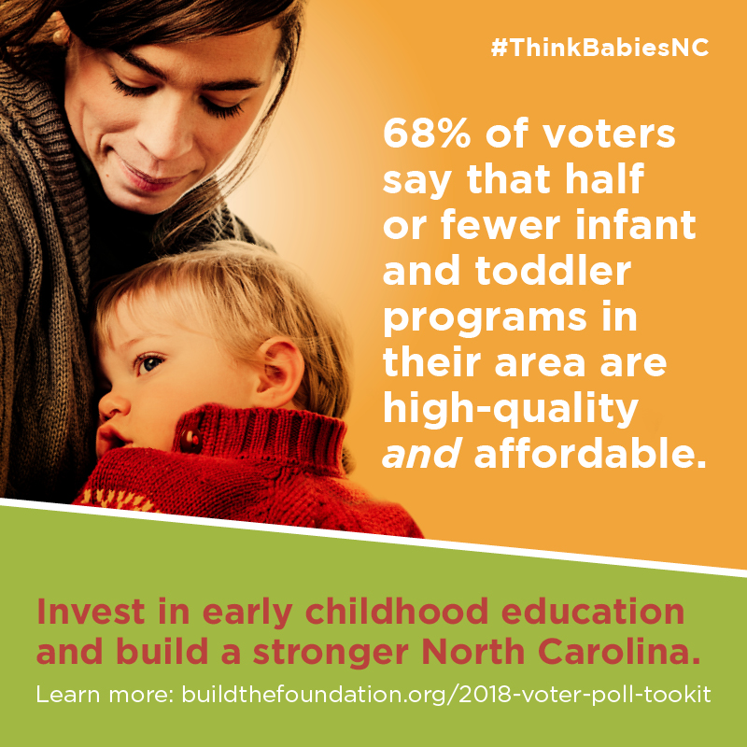

Workforce Compensation and Education
- Infants and toddlers learn through their relationships with the adults in their lives, including their early childhood teachers. Teachers must have the knowledge, skills, and resources to support babies’ healthy development and learning. #ThinkBabiesNC
- Infant-toddler teachers are woefully underpaid, earning an average of $10/hour. Almost ½ of all infant-toddler teachers have relied on some form of public assistance. Worthy work deserves worthy wages. #ThinkBabiesNC
- DYK: infant-toddler teachers are only required to have a high school diploma and 1 course in #earlyed. The national recommendation is a Bachelor’s degree. Teachers need educational knowledge and skills to support babies’ development and learning. #ThinkBabiesNC
- Infant-toddler teachers earn the least of all #ece teachers. Infant-toddler teachers are paid $4/hour less than teachers working with 3-yr-olds, even with a degree. #ThinkBabiesNC
- Early childhood education is the lowest paid field of almost all other occupations. Enrollment in community college #ece programs has dropped by 43% and 1 in 5 infant-toddler teachers predict they will leave the field in 3 years. #ThinkBabiesNC
- Voters recognize that investing in early childhood educators is an investment in children. Build a stronger North Carolina: buildthefoundation.org/2018-voter-poll-tookit #ThinkBabiesNC
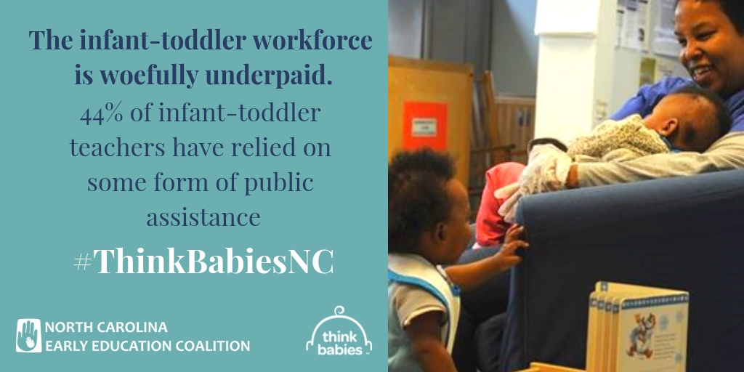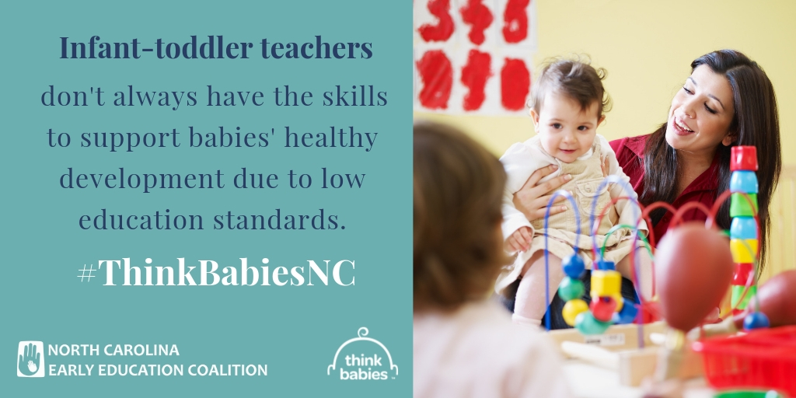
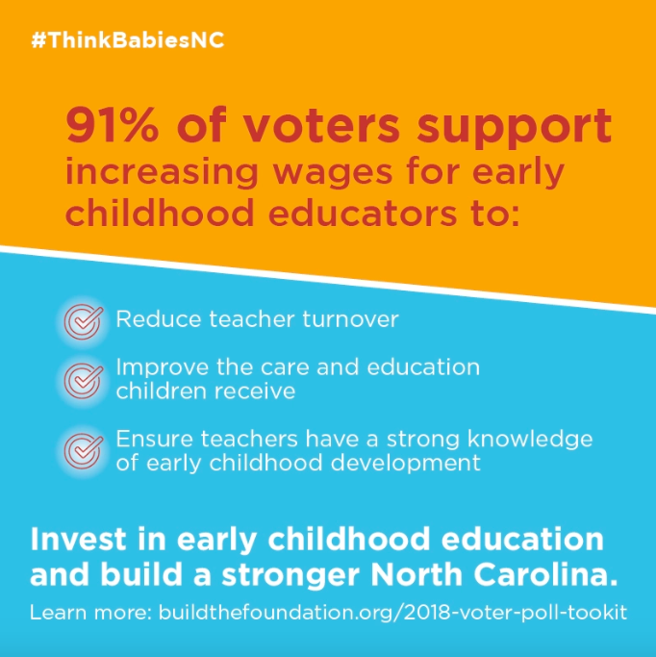

Child Care Quality
- High-quality child care feeds a baby’s growing brain, building the foundation for the development and learning necessary for them to thrive as adults. #ThinkBabiesNC
- The quality of #childcare depends upon the relationship between the provider and the baby, who looks to that caregiver to answer their needs and provide stimulating interactions and learning experiences. #ThinkBabiesNC
- High-quality child care has a proven positive impact on young children’s learning, cognitive and language development, social-emotional health, and future school achievement. #ThinkBabiesNC
- High-quality child care requires a well educated and well compensated workforce with specialized skills and knowledge to support the infants and toddlers in their care. #ThinkBabiesNC
- High-quality care is tough to access, especially for those who need it most. Child care isn’t affordable for many families, and across the state, there is a shortage of high-quality programs serving infants and toddlers. #ThinkBabiesNC

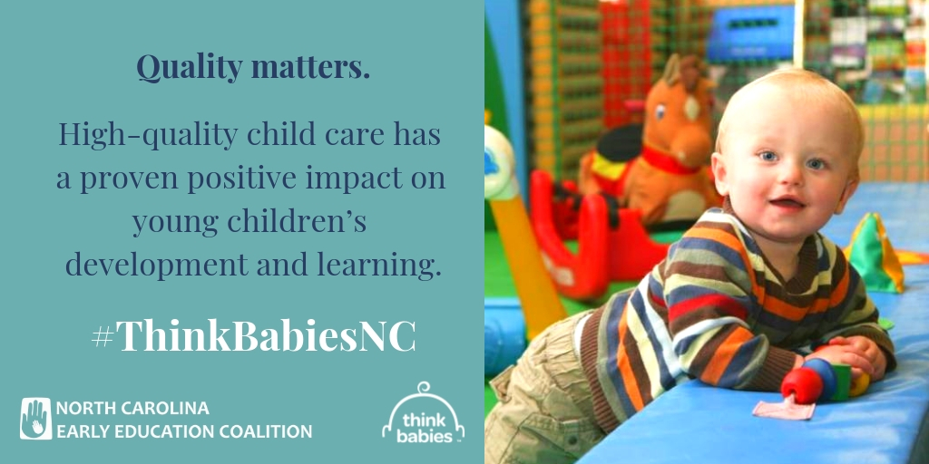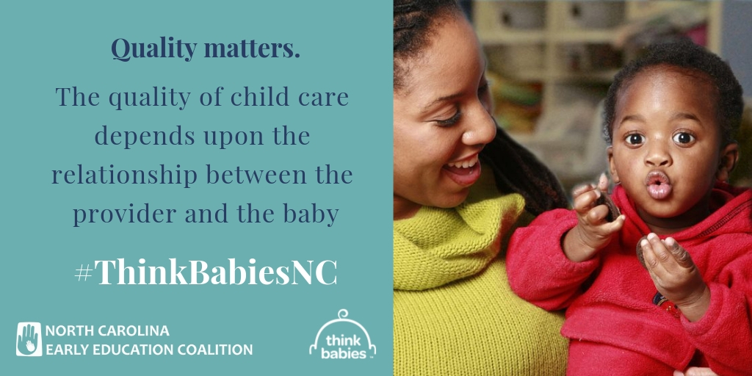

More information and social media tools available at www.ncearlyeducationcoalition.org.

